Project Development Phase
Model Performance Test

Date | 26 June 2025
Team ID | LTVIP2025TMID48374
Project Name | ToyCraft Tales: Tableau's Vision into Toy Manufacturer Data
Maximum Marks

Model Performance Testing:
Project team shall fill the following information in model performance testing template.
S.No. | Parameter | Screenshot / Values
 | Data Rendered | 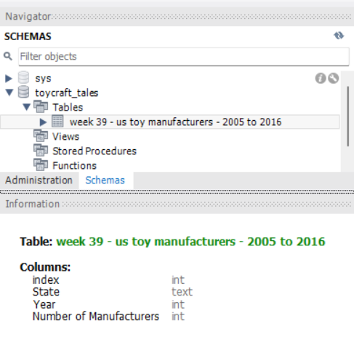  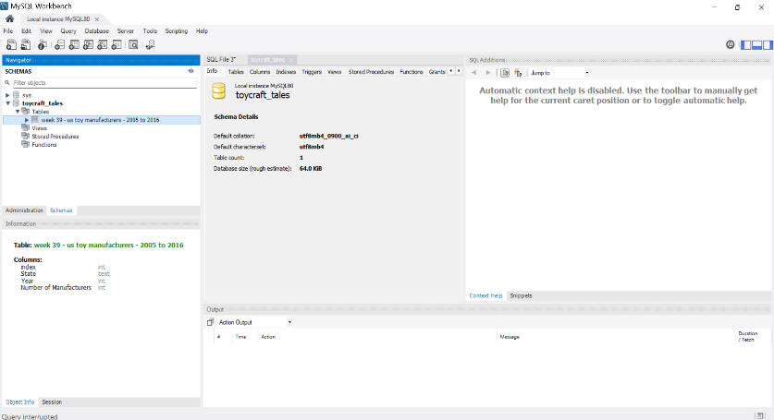
 | Data Preprocessing | 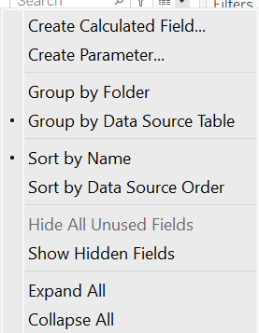  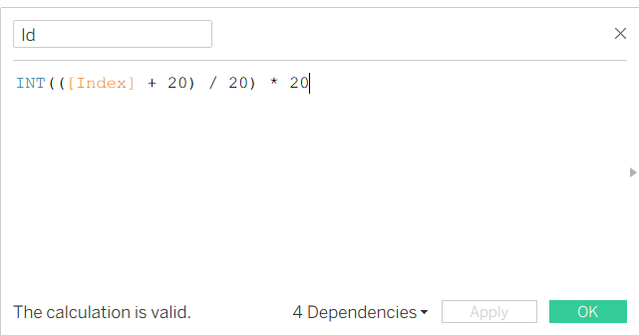  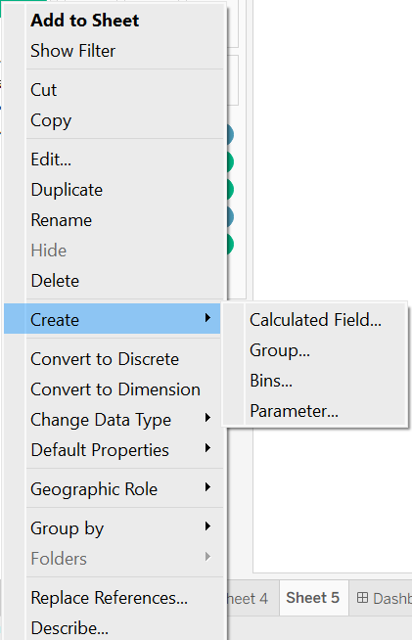  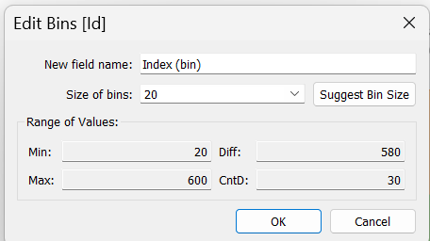
3. | Utilization of Filters | 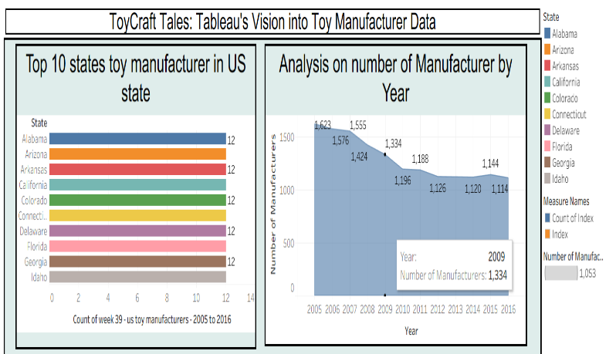  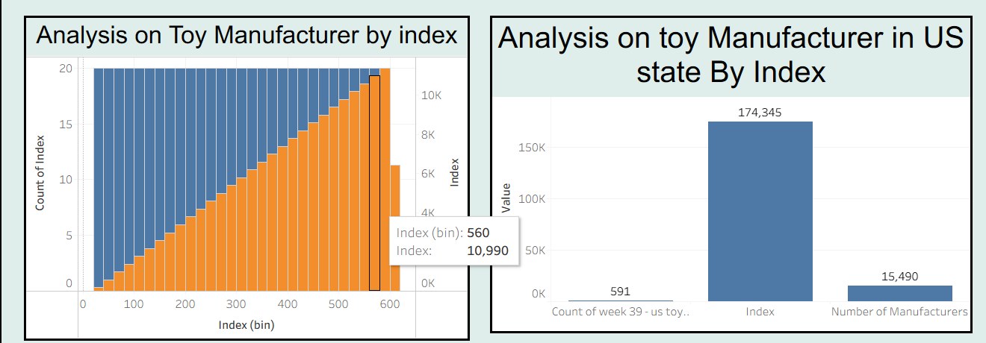  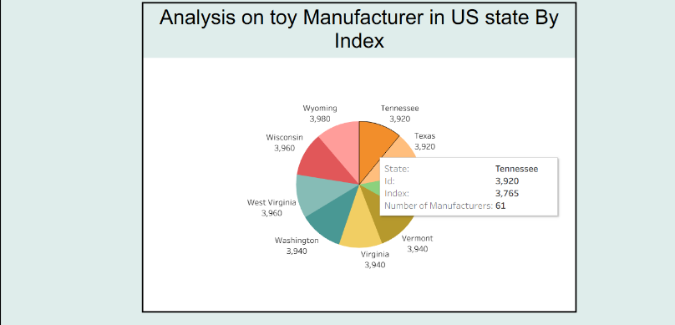
4. | Calculation fields Used | 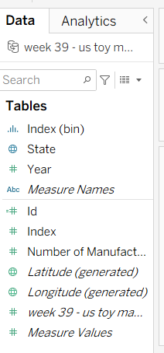
5. | Dashboard design | No of Visualizations / Graphs –  - Analysis of the number of Manufacturers by Year  - Analysis of Toy Manufacturer by Index  - Analysis of toy Manufacturers in US state By Index  - Analysis of Toy Manufacturers  - Top 10 states toy manufacturer in US state  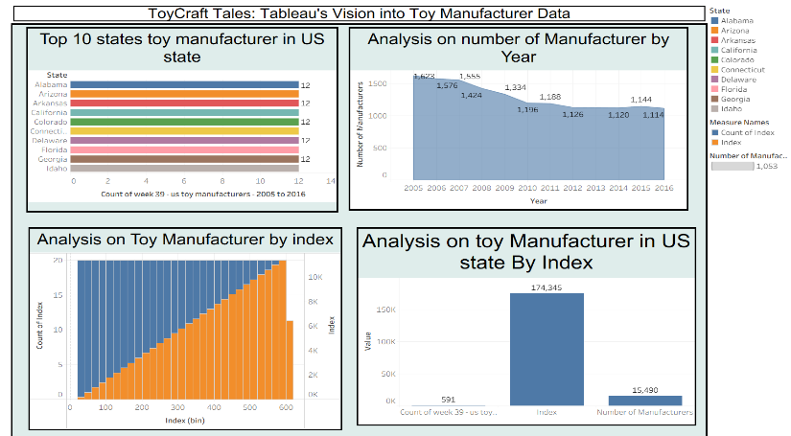  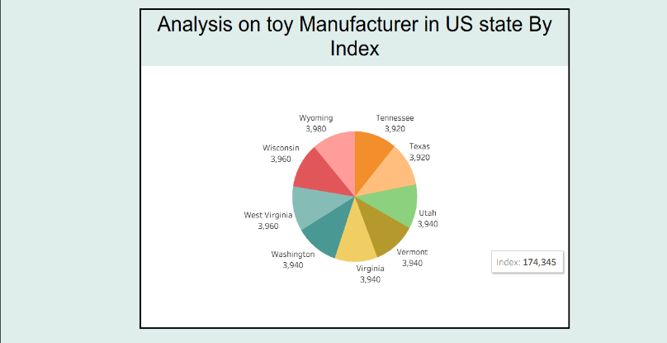
6 | Story Design | No of Visualizations / Graphs –  - Analysis of the number of Manufacturers by Year  - Analysis of Toy Manufacturer by Index  - Analysis of toy Manufacturers in US state By Index  - Analysis of Toy Manufacturers  - Top 10 states toy manufacturer in US state  